In memory of William P. Lentz

March 22, 1918-May 5, 2008

1

In Flanders Fields   
By: Lieutenant Colonel John McCrae, MD (1872-1918)   
Canadian Army

IN FLANDERS FIELDS the poppies blow   
Between the crosses row on row,   
That mark our place; and in the sky   
The larks, still bravely singing, fly   
Scarce heard amid the guns below.

We are the Dead. Short days ago   
We lived, felt dawn, saw sunset glow,   
Loved and were loved, and now we lie   
In Flanders fields.

Take up our quarrel with the foe:   
To you from failing hands we throw   
The torch; be yours to hold it high.   
If ye break faith with us who die   
We shall not sleep, though poppies grow   
In Flanders fields.

2

Just as the spring flower opens its petals to the renewing life, so might we open our hearts to life’s renewing; strength in hope; love in companionship; faith in our eternal destiny.

Like the flowers in the spring, let our expectations rise again and our thankfulness for our lives continue to be renewed. Let us also be grateful for loving hands that have made this food a grand feast.

Loving golden opportunity to strengthen the friendship ties that bind, we are most grateful. For journeys well run, for days yet begun.

HOPE H Helpful O Optimistic P Patience E Endearing

3

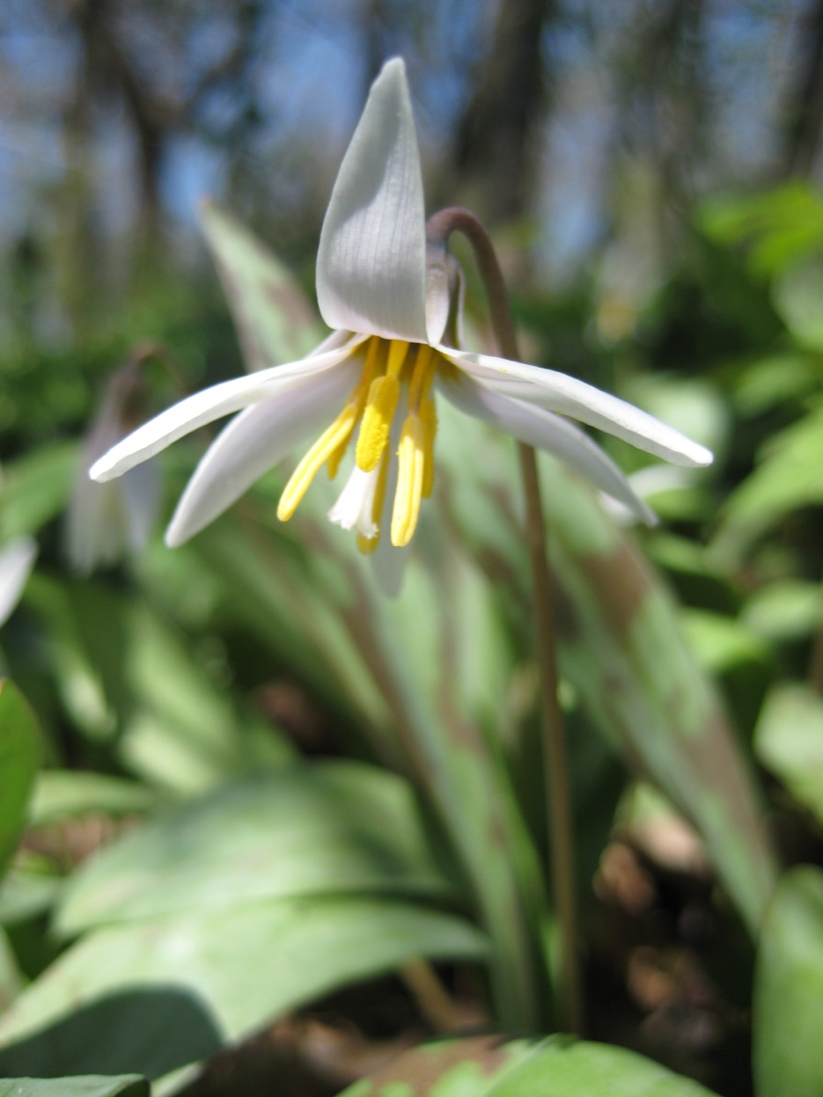

4

Oh Heavenly Father, we like the tall oaks in the forest have weathered many a storm and are stronger for the time given by you and this food to continue life’s celebrations, we would be grateful.

For the power that comes from within, when all else seems forgotten and dim. For loving, kindness, and greatness too Dear Lord, thankfulness we give unto you. Amen.

O, please come, o spirit of life and live within us. May we cry out with joy to see thy handwork; thy loving children; thy fond parents; this food in love prepared.

Dear Heavenly Father, You have given us Life- it is up to us to help it grow. You have given us eyes- it is up to us to see the needs of your children. You have given us hearts- it is up to us to love your children and to seek joy in living with them and ourselves.

5

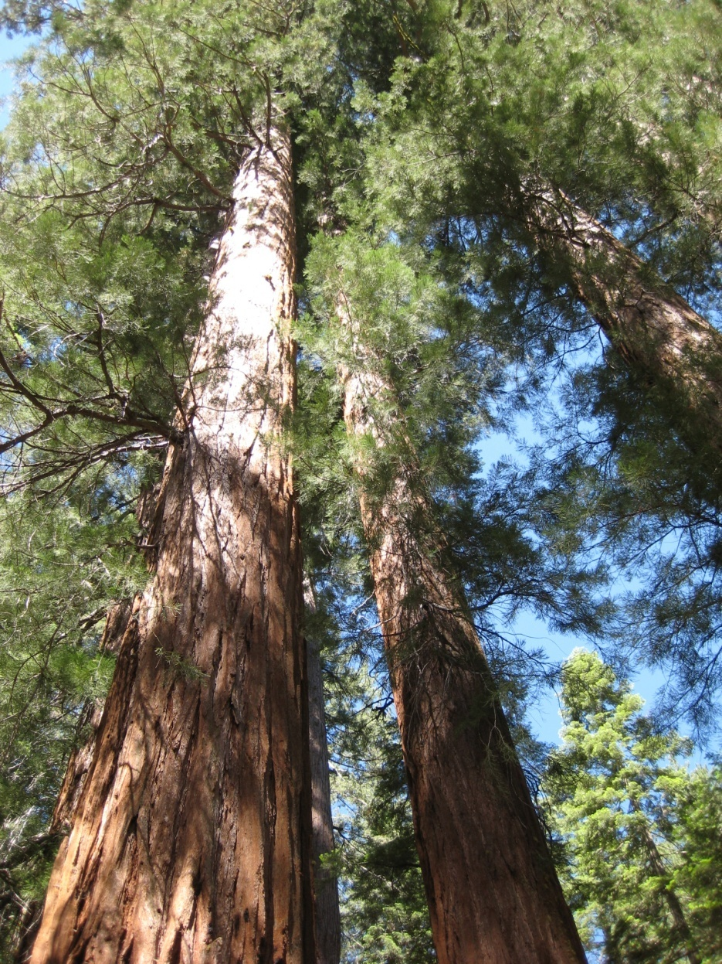

6

Friends, let us toast to the Queen of the feast, Frances. She, for many years of our marriage, has made my birthday a celebration. To you, our esteemed guests, many thanks for being able to come to make a kinglike celebration. To good health for all.

May we rejoice in being at this lovingly given feast; for the hands and heart given in its preparation; for the opportunity presented here in giving comfort and hope to each other. For these blessings may we be grateful

O Heavenly Father we call upon you as giver of life and blessings. We would be ever grateful. May we offer to her loving hands which made this feast possible our thanks. To those gathered here may our regards be extended in many good wishes for health and hopes for much satisfaction in being alive and well.

Dear Heavenly Father, if the truth be confessed, for what we really are thankful for, it is the food so well prepared and the indomitable spirit of Frances’s good will that has made this gathering possible.

O Heavenly Father, you have blessed us with minds to think, hearts to love, and hands to serve. So it’s with heartfelt thanks we are mindful of hands that here serve and we give her our loving thanks.

7

O Heavenly father we accept with pleasure this feast brought by loving hands and the celebration of giving in the life of Frances. This is her birthday and each one of us has cause to be happier because of her. With great gratitude, Amen.

8

May our faith, like a lighthouse on the shore, so shine forth that souls confused and lost may be guided to renewed hope and trust in the living Lord. For the food lovingly here prepared lend strength to our purpose.

May thy spirit, O Heavenly Father, lead us to the serenity of this savory table…leaving behind us the noise of worldly confusion.

O Heavenly Father we seek thy spirit becoming alive in our hopes. Our Pandora’s boxes cry out their emptiness in today’s difficult times. Fill us with renewed strengths of shining expectations. Be at this our renewal feast of love. In thy spirit we say Amen.

Let us make this brief slice of eternal time a joyous memory and may we be not afraid of facing with hope a future of many possibilities.

9



10

Give me but a moment in thy temple, O Lord, and I will proclaim thy majesty. Give me but a moment with my grandchildren and friends and I will proclaim my God is love.

O let us come to gather in joy and celebration, for our moments with each other are pleasant. Would that the golden cord last forever.

O, Heavenly Father, we call upon thy name in fulfillment of the promise that when two or three are gathered, thou also will be present. We thank thee for life itself and this moment of enjoyment together as we share good food. Amen

Bless we more thy name, O Creator, who has promised that whenever two or more are gathered in thy name, thou also will be with us.

O Lord we light again the warming glow of friendship’s fires, and here we are grateful that each shining ember adds to the warmth of our celebration burning in thankfulness.

For hearts that love dearly For hands that serve sincerely For eyes that see clearly May we be led to God more nearly (Lead us to God more nearly)

11

12

Like the flowers in the spring, let our expectations rise again and our thankfulness for our lives continue to be renewed. Let us also be grateful for loving hands that have made this food a grand feast.

We honor a tradition and we honor our forbearers who kept it alive; that we thank the Almighty for live-giving sustenance and our existence in his universe.

In truth we are members of a human family and truly also we are members of God’s family, for it is he who has bequeathed to us Life itself.

Oh Heavenly Father we seek thy presence and blessing on our earthly feast. In thy spirit may we continue to grow; to feel the joys of sharing; to enlarge our outlook on the many changes in life. In the confused hopes for a better tomorrow may we serve as messengers. For the many loving hands making this meal possible we offer thanks. Amen

As we welcome the good food, we raise our thanks to thee our Heavenly Father; our life-long benefactor

13

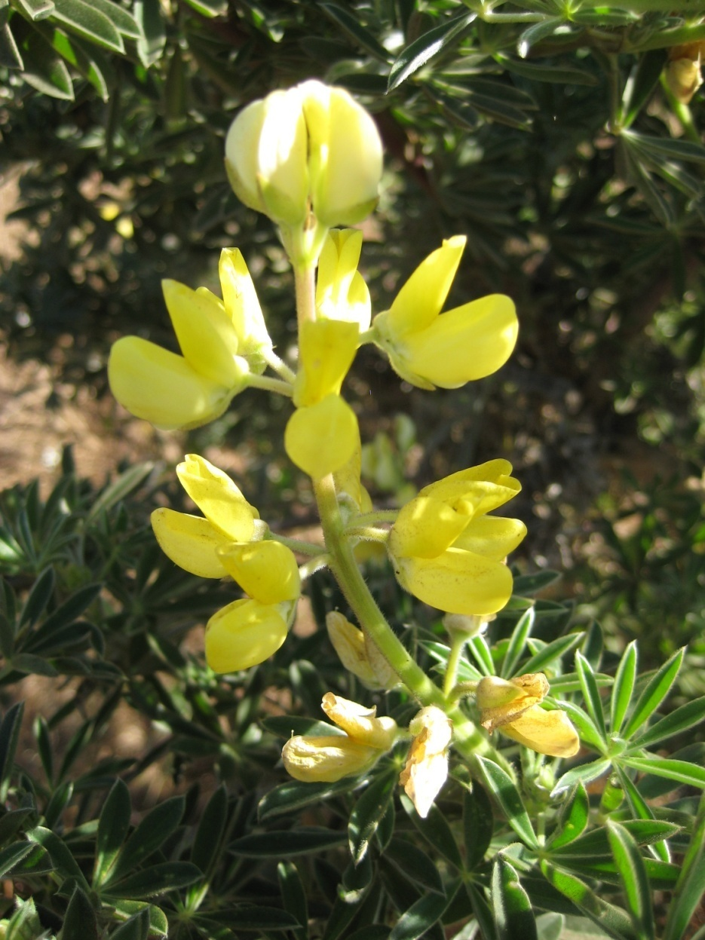

14

Sometimes I feel like a pebble on the beach: tossed up by the tide, buffeted by the storms, left baking in the midday sun. Yet do I love my fellow pebbles, for we share life on your beach, our Heavenly Father.

As we tread the prickly path of life, may we be guided by thy light and strengthened by this food.

15

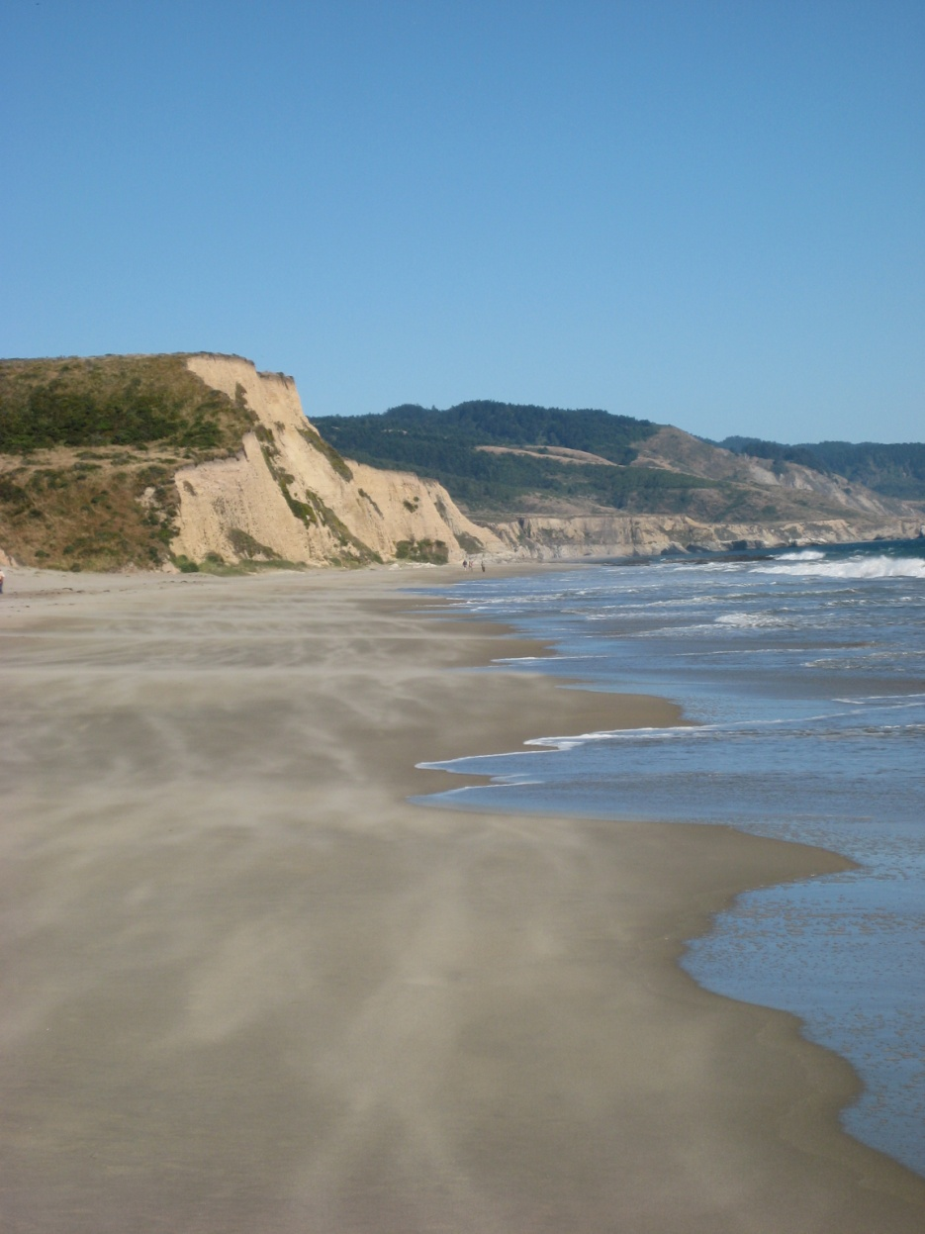

16

Let us be reminded as we see the full moon of recent nights of the great story of the release of the children of the covenant from slavery into freedom. May we ever serve one another in defense of freedom.

Father of mercy, o continue thy loving kindness unto me and unto my dear ones. Make me worthy to rear my children that they walk in the way of the righteous before thee, loyal to thy law and clinging to good deeds. Keep thou from us all manner of shame, grief, and care; and grant that peace, light, and joy ever abide in our home.

O Heavenly Father, on this day special for Americans we are grateful: for brave forbearers, for loved ones whose lives enriched ours, our hopes for growth in years to come. In appreciation for loving hands that prepared this feast, we say Amen.

O Heavenly Father, Lord of Life, we are thankful for this golden moment made bright by family and friends. We celebrate the food and friendship of many; for heartwarming encounters spanning years of growing. We are grateful for those dear to us whose earthly lives shall shine forever in our memory. We thank thee for giving life to generations yet to come. May they too have occasions for public gratitude.

17

18

Make us too brave to lie or be unkind.  
Make us too understanding, too, to mind  
The little hurts companions give, and friends,-  
the careless hurts that no one quite intends.  
Make us too thoughtful to hurt others so.  
Help us to know the inmost hearts of those for whom we care-  
Their inner burdens, all the loads they bear;  
That we may add our courage to their own.  
May we make lonely folks feel less alone,  
And happy ones a little happier yet.  
May we forget all  
That ought to be forgotten and recall  
Unfailing, all  
That ought to be recalled- each kindly thing,-  
Forgetting what might sting.  
To all upon our way,  
Day after day,  
Let us be hope, be joy. Let our lives sing!  
  
~Mary Carolyn Davies

20

19